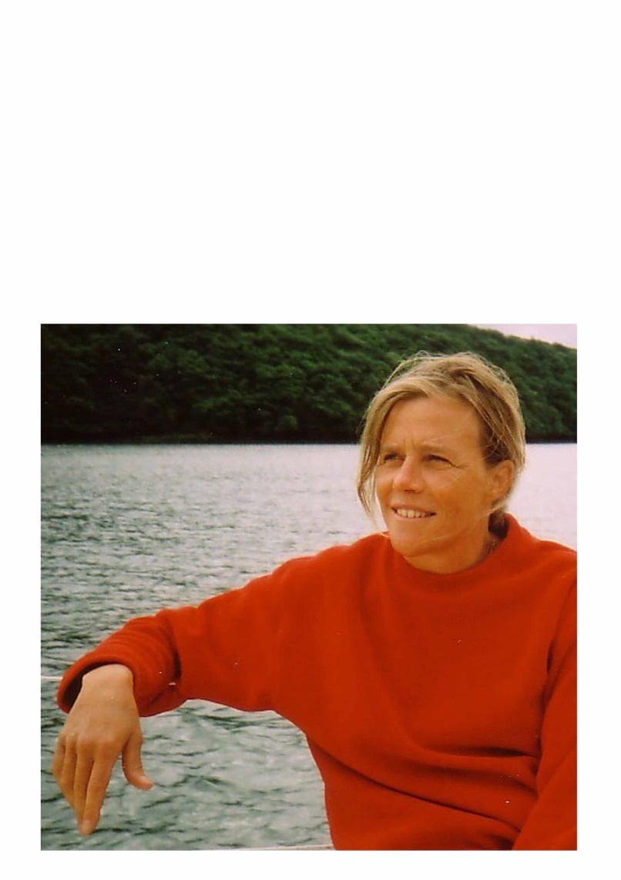
Caroline Lopez
06.25.35.30.41

Cité Nicolas Poussin
242 bd Raspail 75014 Paris
Code: 8596 – porte 2

carolinelopez65aiai@gmail.com

facebook: Imaginer ZEPOL
blog: Imaginer ZEPOL (illustration65zepol.blogspot.com)

